**Empathy Map Canvas**

|  |  |
| --- | --- |
| 📅 Date | 31 January 2025 |
| 👥 Team ID | LTVIP2025TMID31117 |
| 👥 Team Size | 4 |
| 👑 Team Leader | Sai Vinay Biruda |
| 👤 Team Members | - Pilli J V Durga Prasanna Kumar  - Pradeep Kumar  - Pattucharla Lakshmi Anjana Sridevi |
| 📌 Project Name | Workforce Administration Solution (Dev) |

### Empathy Map Canvas

|  |
| --- |
|  |

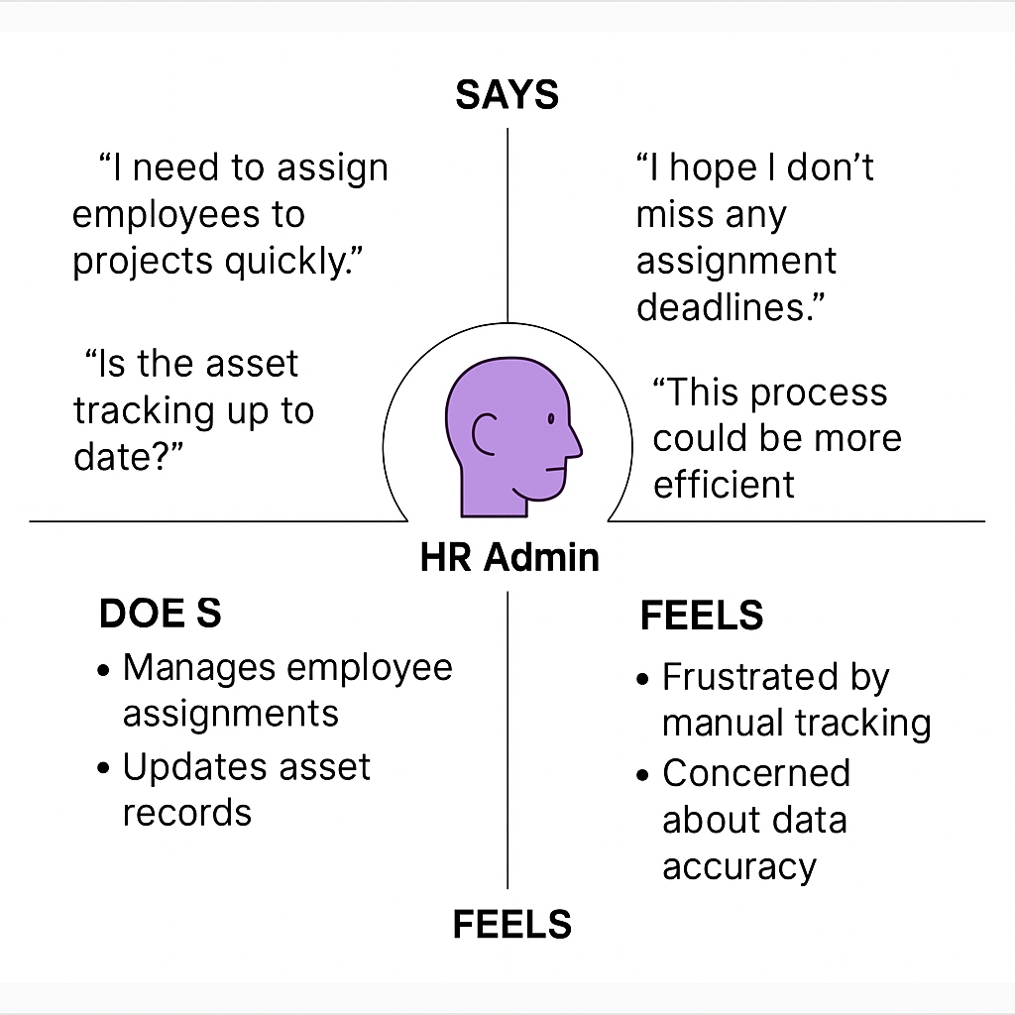

📄 Sample Record Detail Page

Below is a sample Salesforce record detail page for the Employee/Asset object. This illustrates how our proposed custom objects would appear in the Salesforce interface, supporting workforce administration.

